**Snowflakess**

**What is Snowflake:-**

Snowflake is a **cloud-native data platform** that separates storage from compute. Unlike traditional data warehouses that require significant up-front hardware, complex setup, and ongoing maintenance, Snowflake runs entirely on the cloud (AWS, Azure, or GCP). This means you pay only for the resources you actually use, and you can scale up or down as your data or query needs fluctuate.

**Key Benefits Include:-**

* **Scalability:** Instantly scale compute resources up or down to handle peaks in workload, then scale back to minimize costs.
* **Performance:** Run complex queries efficiently with Snowflake’s highly optimized engine.
* **Ease of Use:** A fully managed service means less time spent on maintenance, tuning, and capacity planning.
* **Security & Compliance:** Built-in security features, encryption, and compliance certifications keep your data protected.
* **Data Sharing:** Securely and seamlessly share data between organizations without having to move or copy it.

**Before You Begin:-**

Before diving into Snowflake, it’s helpful to understand a few core concepts:

1. **Warehouses:** In Snowflake, a “warehouse” is a virtual cluster of compute resources. Think of it as the engine that executes your queries. You can have multiple warehouses for different workloads (e.g., one for data loading, another for analytics).
2. **Databases and Schemas:** Snowflake organizes data into databases and schemas, much like a traditional relational database system. Within a database, a schema stores tables and views. This logical hierarchy helps keep your environment tidy and organized.
3. **Tables, Stages & Files:** You’ll load your raw or processed data into tables. Stages (either internal or external, like Amazon S3) are used as intermediaries for loading and unloading data, ensuring you can seamlessly move data in and out.
4. **SQL Knowledge:** Snowflake uses SQL as its main query language. Basic SQL proficiency goes a long way. If you’re new to SQL, brushing up on SELECT, JOIN, and GROUP BY commands will help you hit the ground running.
5. **Getting Started Step-by-Step**

**Step 1:-**

Sign Up for a Free Trial Head over to [Snowflake’s website](https://www.linkedin.com/redir/redirect?url=https%3A%2F%2Fwww%2Esnowflake%2Ecom%2F&urlhash=aNqS&trk=article-ssr-frontend-pulse_little-text-block) and sign up for a free trial. Once you’ve completed the registration, Snowflake provides a temporary environment with free credits so you can experiment without upfront costs.

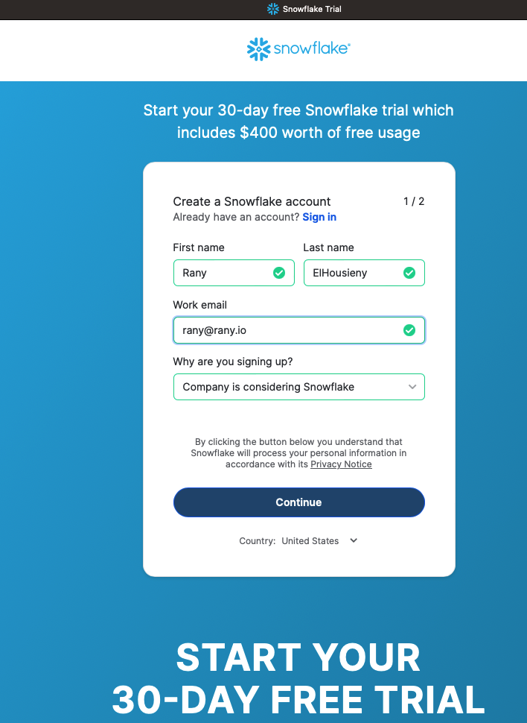

**Step 2:-**

Choose a Cloud Provider During the setup, you’ll pick from AWS, Azure, or Google Cloud Platform. If you already have a preferred cloud provider, stick with that for easier integration. If not, choose any—the Snowflake experience remains consistent.

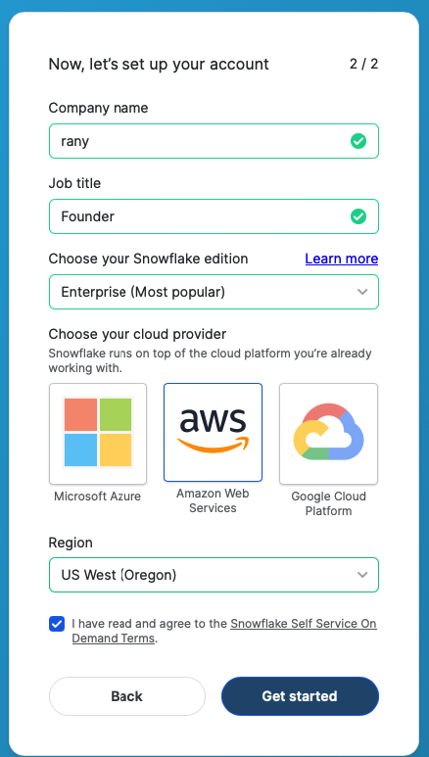

**Step 3:-**

Familiarize Yourself with the Web UI After signing in, you’ll find yourself in the Snowflake web interface. From here, you can explore databases, write queries, manage warehouses, and monitor usage. Take a few minutes to click around and learn where everything is.

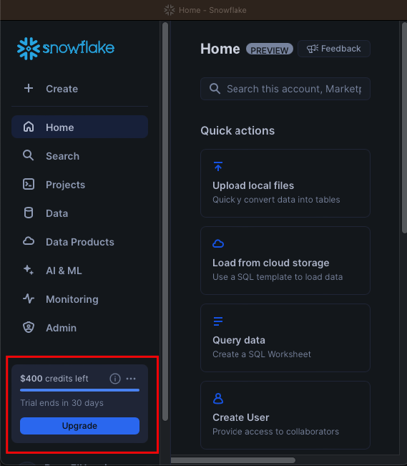

**Warehouses:-**

In Snowflake, warehouses are virtual clusters of compute resources responsible for executing queries and performing data operations such as loading, transforming, and analyzing data. They are not physical servers but scalable, on-demand compute engines that Snowflake provides as part of its

cloud architecture.

**Key Features of Warehouses:-**

1. Compute Power: A warehouse processes SQL queries and handles tasks like data ingestion and processing.
2. Scalability: You can easily scale warehouses up (increase size) for faster performance or down to save costs.
3. Pay-Per-Use: Snowflake charges for warehouse usage only when it is active, enabling cost control.
4. Multiple Warehouses: You can create multiple warehouses for different workloads, such as separating analytics, ETL (data loading), and reporting.

**Why Start with Warehouses:-**

Warehouses are fundamental to query execution in Snowflake. Without a warehouse, you cannot run queries or perform operations because there is no compute power allocated.

In Step 4, you start with creating a warehouse because:

1. Queries Need Compute Resources: Warehouses are required to run any SQL commands, including querying and analyzing data.
2. Cost Control: Starting small allows you to experiment without incurring significant costs.
3. Separation of Workloads: By creating a warehouse early, you can manage workloads (e.g., ETL vs. reporting) efficiently as you grow.
4. Think of a warehouse as the engine of Snowflake—creating one early ensures you have the compute power necessary to load data, explore it, and perform operations.

**Step 4:-**

**Create Your First Warehouse:-**

First, Make sure you select the AccountAdmin

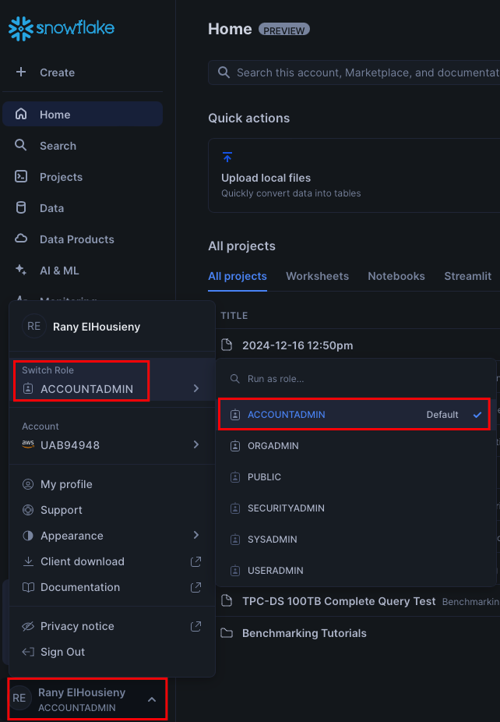

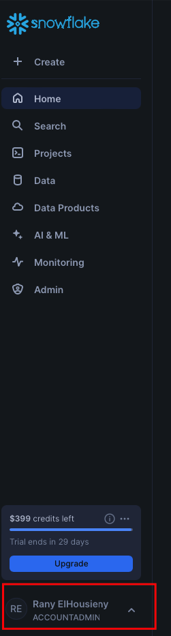

Navigate to the “Admin\Warehouses” section and create a new warehouse. It only takes a few clicks. Begin with a small size—Snowflake uses a pay-as-you-go model, so starting small ensures you won’t incur unnecessary costs.

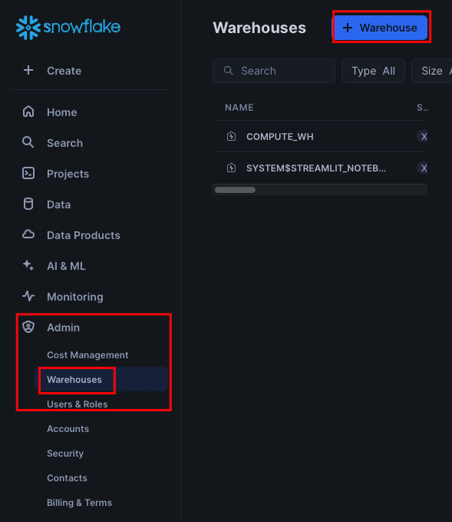

**🡪New Warehouse**

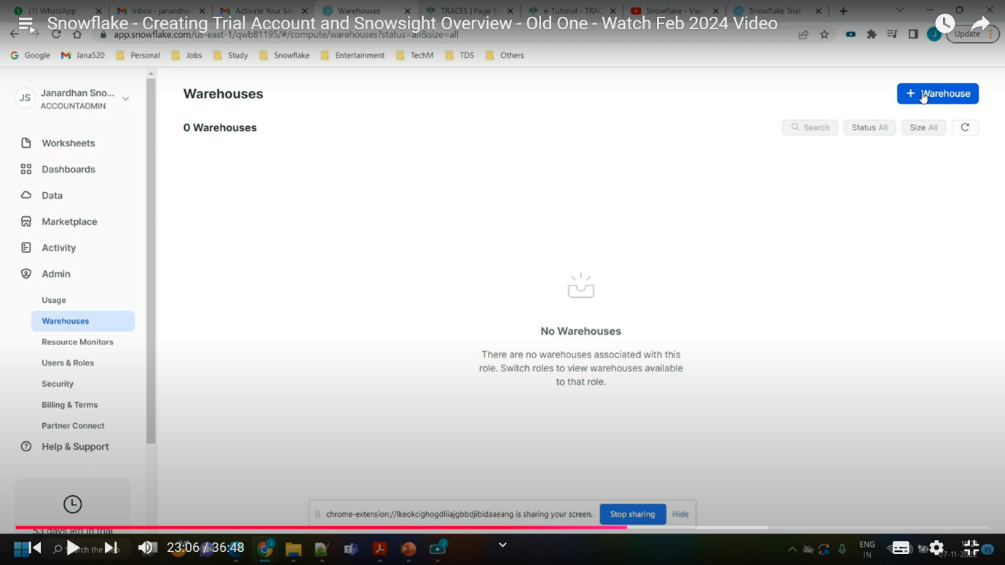

**🡪New Warehouse Name**

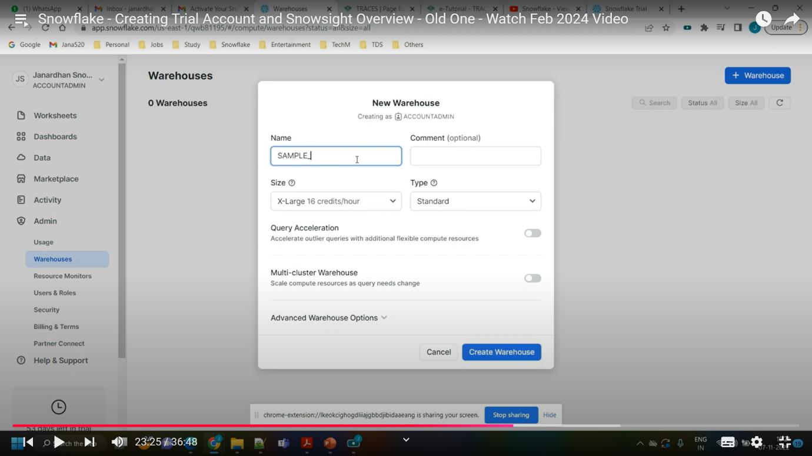

* **Select Size**

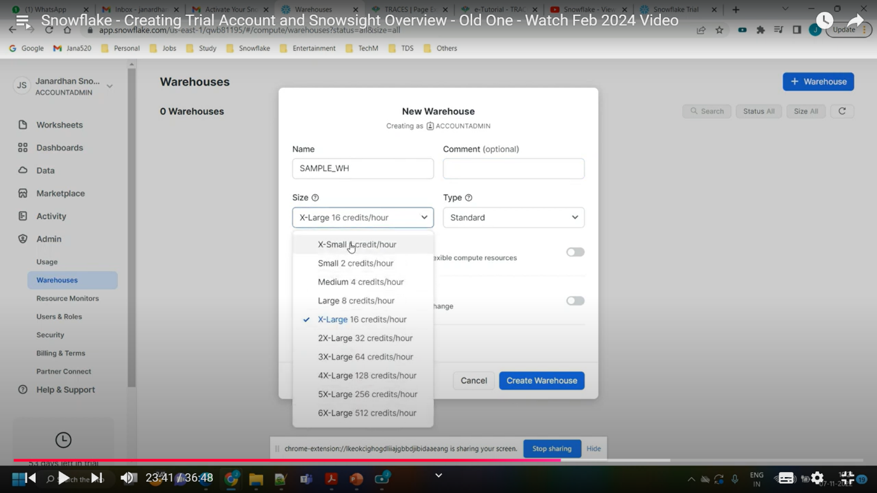

* **Select Type**

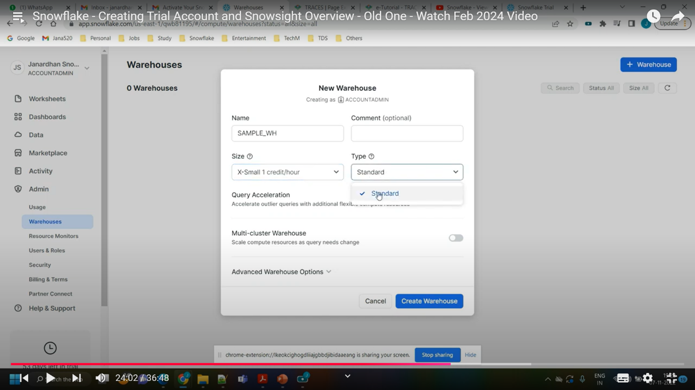

* **Multi Cluster Warehouse**

